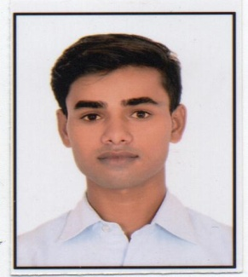
ROHIT SHARMA

PIHANI CHUNGI SHAHJAANPUR ROAD
DISST HARDOI 241001 UP
Contact No:+91-9936982215,8887569595
Email- rohit24sharma1001@gmail.com
Objective:
Intend to build a career with Hotel organization with committed& dedicated people, which will helpline to explore myself fully and realize my potential towards innovative environment.

PROFESSIONAL QUALIFICATION:
- Diploma course in Hospitality, Travel and Customer service from Frankffinn, Lucknow in(2017,18)
- Course on Computer concept ( CCC ) FROM NIELIT May 2017

EDUCATIONAL QUALIFICATION:

- B.Com from C.S.J.M. University, Kanpur
- Intermediate from U.P. Board in 2016
- High School from U.P. Board in 2014

PERSONAL SKILLS:

- Adaptable
- Self-Motivated
- Energetic
- Team Leader
- Emphatic

AREA OF SPECIAL ACHIEVEMENT:
- Certificate of Excellence from Customer Interaction Program
wORK EXPERIENCEL:
- Industrial Training in Front Office Department at Chokhi Dhani Resort Jaipur From 10 Sep 2018 to 09th March 2019.
- Worked With Ranjees Hotel Lucknow
Front Office Associate April 2019 to April 2020
- Worked with Pre – Opening property at Anchaviyo Resort Mumbai
Front Office Associate 16th September 2020 to 18th March 2021
- Worked with Sun Hotel and Resorts Abu Road Rajasthan
Senior GSA 1st January 2021 to 1st Jun 2021
- Currently working with Best western country woods Ambala Haryana
Front office supervisor from 4th of June 2021 to 10th June 2022

SOFTWARE KNOWLADGE
BINIX
IDS
Ezee absolute
Personal Profile:
  - Date of Birth : 15/07/1998
  - Father’s Name : Mr. Om Prakash
  - Marital Status : Unmarried
  - Language Known : Hindi & English
  - Nationality : Indian
  - Passport No : S5404328

Date:
Place: Rohit Sharma

